FOENIX K2 & JR JR
NEW CORE X2 DEFINITIONS

IO CTRL

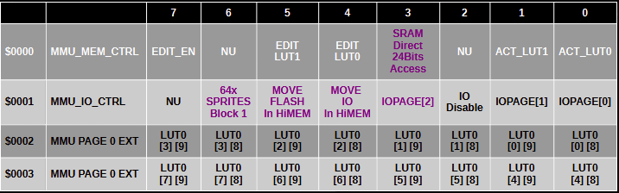
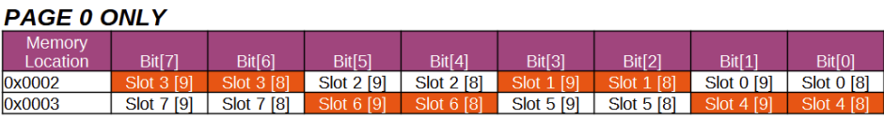

MMU SYSTEM FOR X2 CORES
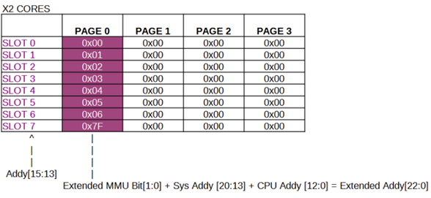

BANKS IN X2 CORES
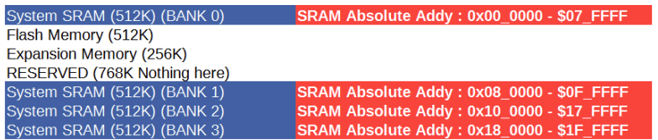
To Compose the SRAM Address
- Only the bit[5:0] are used in the MMU Output Value (for the selected slot),
- Then the new bit on Register $0002 + $0003 are added depending again on the slot # (this will work only with the Page 0)
So for an example of SRAM Address, let's say we used slot #1 and we want to access SRAM 512K Bank 1.
- The Value for address $0007 would be $01 (CPU Mem: $2000 - $3FFF (when page 0 is selected)
- Value for address $0002 would be $04
And that would give you access to : $08_2000 in absolute address, So bit[9:8] of $0002 or ($0003) + MMU Bit[5:0] + CPU Addy [12:0]

REGULAR MMU DECODING (NON X2 MODE)
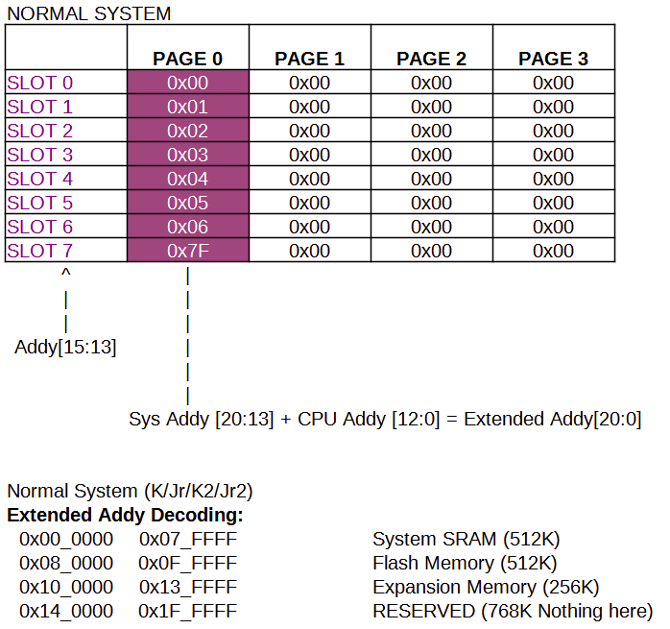
VICKY CTRL REGISTERS CHANGES
MASTER_CTRL_REG_L = $D000
Mstr_Ctrl_Text_Mode_En = $01 | Enable the Text Mode
Mstr_Ctrl_Text_Overlay = $02 | Enable the Overlay of the text mode on top of Graphic Mode (the Background Color is ignored)
Mstr_Ctrl_Graph_Mode_En = $04 | Enable the Graphic Mode
Mstr_Ctrl_Bitmap_En = $08 | Enable the Bitmap Module In Vicky
Mstr_Ctrl_TileMap_En = $10 | Enable the Tile Module in Vicky
Mstr_Ctrl_Sprite_En = $20 | Enable the Sprite Module in Vicky
Mstr_Ctrl_GAMMA_En = $40 | Enable the GAMMA correction - The Analog and DVI have different color value, the GAMMA is great to correct the difference
Mstr_Ctrl_Disable_Vid = $80 | This will disable the Scanning of the Video hence giving 100% bandwith to the CPU

MASTER_CTRL_REG_H = $D001
Mstr_Ctrl_Video_Mode = $01 | 0 - 640x480@60Hz :  1 - 640x400@70hz (text mode)  0 - 320x240@60hz  1 - 320x200@70Hz (Graphic Mode & Text mode when Doubling = 1)
Mstr_Ctrl_Text_XDouble = $02 | X Pixel Doubling
Mstr_Ctrl_Text_YDouble = $04 | Y Pixel Doubling
Mstr_Ctrl_Turn_Sync_Off = $08 | 1 = Turn off Sync
Mstr_Ctrl_Show_BG_InOverlay = $10 | 1 = Allow the Background color to show up in Overlay mode
Mstr_Ctrl_FONT_Bank_Set = $20 | 0 =(default) FONT Set 0, 1 = FONT Set 1
Mstr_Ctrl_Text_MEM_Enable = $40
Mstr_Ctrl_Text_MEM_BG_En = $80

MASTER_CTR_REG_2 = $D00A
HW_Line_Drawing_Enable = $01 | 0 - Disable Line drawing  (This also enables +64 Additional Sprites  1 – Enable HW Line drawing  (Disables Additional Sprites)

NEW MEMORY RELOCATABLE TEXT MODE
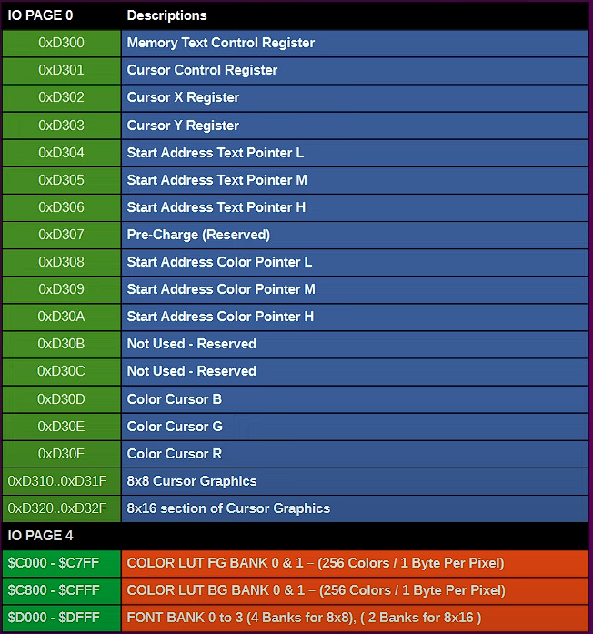

NEW CHARACTER ATTRIBUTES
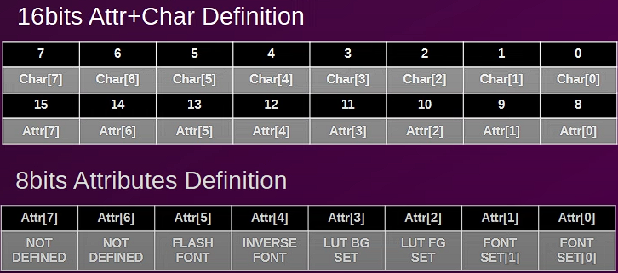

HARDWARE BRESENHAM LINE DRAWING
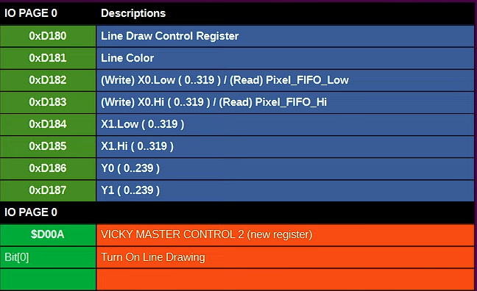

FLOATING POINT BLOCK
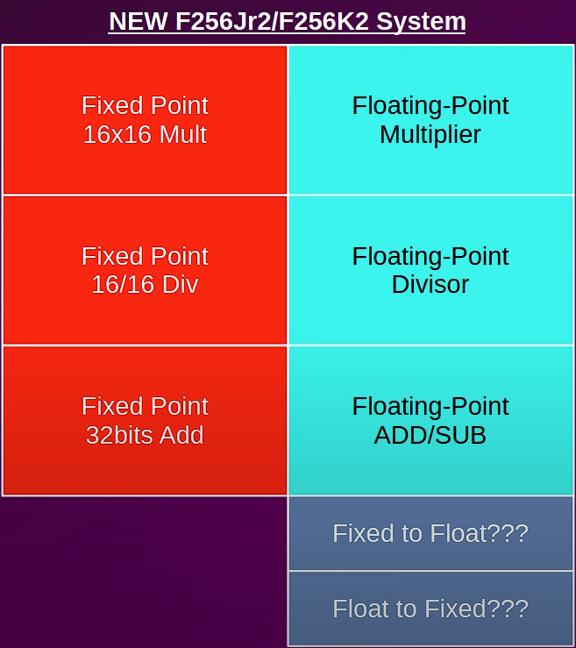

BLOCK DIAGRAM FOR FLOAT COPROCESSOR
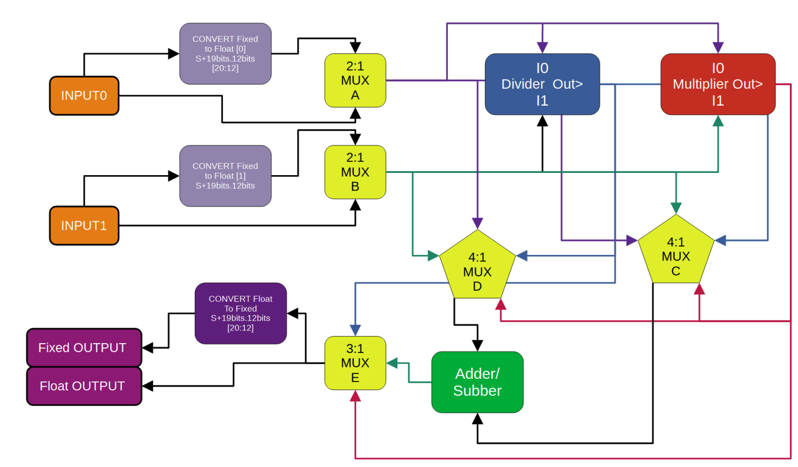

$DE80: Control Register
Bit[0] = MUXA Ctrl | 0 = User Input0  1 = Converted User Input0  (Fixed [20:12] -> Float 32bits)
Bit[1] = MUXB Ctrl | 0 = User Input1  1 = Converted User Input1  (Fixed [20:12] -> Float 32bits)
Bit[2] = Not Used
Bit[3] = Addition Block TValid**
Bit[5:4] = MUX C Ctrl | 00: Output of MUXA  01: Output of MUXB  10: Mutiplier Output  11: Divider Output
Bit[7:6] = Mux D Ctrl | 00: Output of MUXA  01: Output of MUXB  10: Multiplier Output  11: Divider Output

$DE81: Control Register1
Bit[1:0]: MUXE Ctrl | 00: Multiplier Output  01: Divider Output 2'b10: Adder Output  11: Float Value of 0 (0x3F80_0000)

$DE82: Control Register2
Bit[0] | Converter 0 TValid
Bit[1] | Input 0 TValid
Bit[2] | Converter 1 TValid
Bit[3] | Input 1 TValid

DATA REGISTERS FOR FLOAT OPERATIONS
$DE83: Not Used
//Write
$DE87:$DE84: Not Used (Write Only)
$DE8B:$DE88: USER Input0 (Little Endian) (Write Only)
$DE8F:$DE8C: USER Input 1 (Little Endina) (Write Only)
// Read
$DE80: Control Register 0
$DE81: Control Register 1
$DE82: Control Register 2
$DE83: Control Register 3
$DE84: Status Register 0 (to be detailed Later)
$DE85: Status Register 1 (to be detailed Later)
$DE86: Status Register 2 (to be detailed Later)
$DE87: Status Register 3 (to be detailed Later)
$DE8B:$DE88: FLOAT OUTPUT
$DE8F:$DE8C: CONVERTED OUTPUT [20:12] Format S+19.12
CHANGES TO DMA CONTROLLER
VDMA_CONTROL_REG = $DF00
VDMA_CTRL_Enable [0]= $01 | 0: Disable DMA  1: Enable DMA
VDMA_CTRL_1D_2D [1]= $02 | 0: 1D (Linear) Transfer  1: 2D (Block) Transfer
VDMA_CTRL_TRF_Fill [2]= $04 | 0: Transfer Src -> Dst  1: Fill Destination with "Byte2Write"
VDMA_CTRL_Int_Enable [3]= $08 | 0: No Interrupts Generated  1: Enable the Generation of Interrupt when the Transfer is over.
NOT USED [4]= $10 | Reserved
NOT USED [5]= $20 | Reserved
SixteenBit_Enable [6]= $40 | 0: 8 bit transfers  1: to Do a 16 bits Transfer  (Even TO Even Address Only)
VDMA_CTRL_Start_TRF [7]= $80 | 0: Clear - Needs to be Cleared before you can start a transfer  1: Begin Process

